ALPHA ARTS AND SCIENCE COLLEGE


AI STUDYBUDDY
AI Assistant for Smarter Learning and Study Support
Project Documentation

TEAM DETAILS
Team Leader : Kishore Anantham.G.M
NM ID : 3ABE7FAA7149C37B4C04A93C5B959F4D
Team Member : Jeevananthan.V
NM ID : 346B960D3A0EDC983BE4BD1E6CCE71D1
Team Member : Saravanan.S
NM ID : 6820E3BE5A7C58AB71444A18A0B6DF83
Team Member : Samson.D
NM ID : C34394F5F6AA2FDB2F84C9BAB8F50B69

PROJECT DETAILS
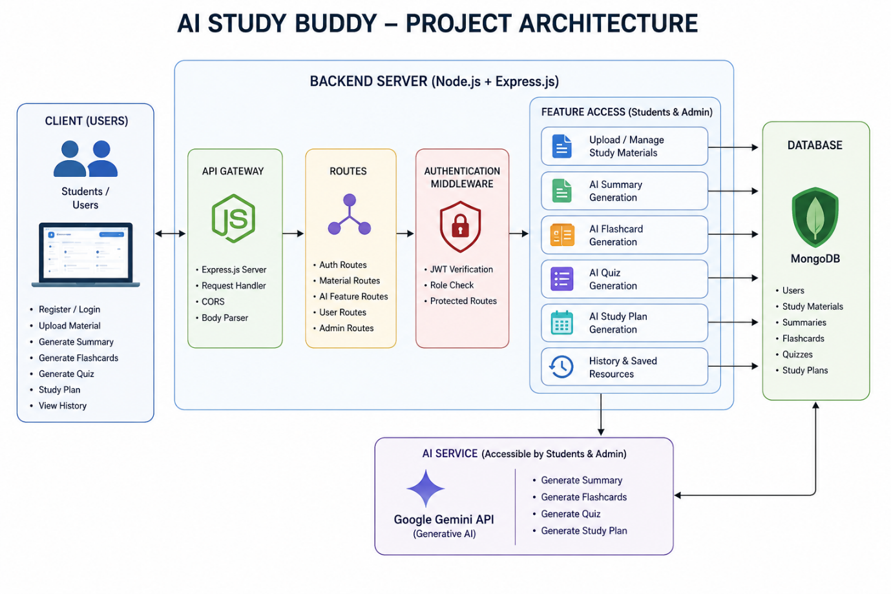
Project Title | AI StudyBuddy – AI Assistant for Smarter Learning and Study Support
Application Type | AI-powered learning assistance platform
Architecture | Secure RESTful backend architecture
Primary Database | MongoDB
AI Service | Google Gemini API
Authentication | JWT-based authentication and Role-Based Access Control (RBAC)

OBJECTIVE
To develop an AI-powered learning assistance platform that simplifies the study process by allowing students to upload or enter study materials and automatically generate concise summaries, flashcards, multiple-choice quizzes, and personalized study plans. The system reduces manual preparation time, supports effective revision, and provides secure, centralized access to AI-generated learning resources.
Entity-Relationship (ER) Diagram Description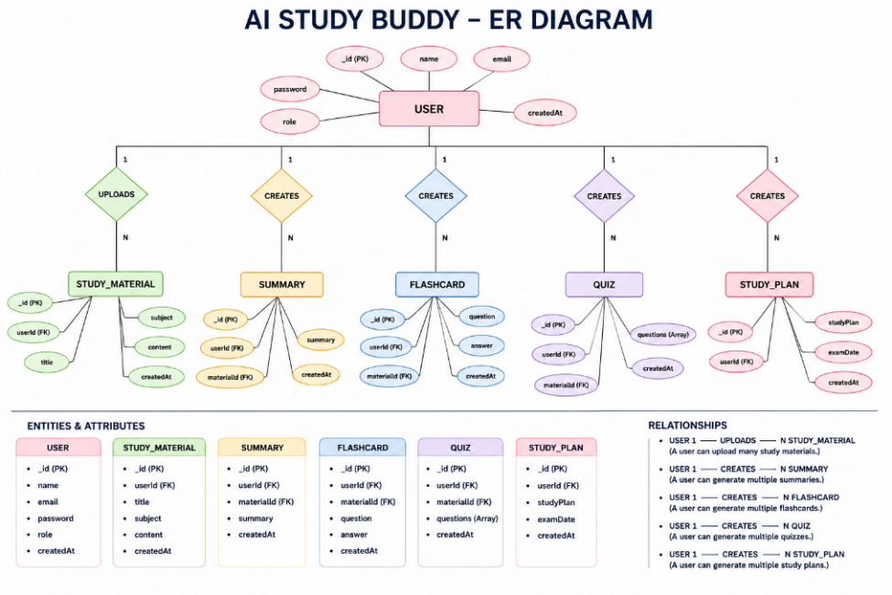

BACKGROUND
Students may prepare for examinations and technical learning while their study materials are scattered across lecture notes, PDFs, textbooks, online articles, and handwritten notes. Manually summarizing lengthy content, preparing flashcards and practice questions, and creating revision schedules can be repetitive and time-consuming.
- Difficulty understanding lengthy study materials within limited time.
- Manual preparation of notes consumes significant study time.
- Creating flashcards and revision questions is repetitive and labor-intensive.
- Lack of personalized study plans based on available time and examination schedules.
- No centralized platform to securely store AI-generated learning resources.
- Difficulty assessing knowledge through self-generated quizzes.
- Switching between multiple applications reduces productivity.

SOLUTION
AI StudyBuddy provides a centralized AI-powered learning platform that automates academic content-generation tasks. Authenticated users can upload study materials or provide textual content and select the required AI functionality. The backend processes requests through secure RESTful APIs and communicates with the Google Gemini AI model to generate learning resources.
- JWT-based user authentication and protected routes.
- MongoDB storage for user information and study resources.
- AI-generated concise summaries for faster revision.
- AI-generated flashcards for active recall learning.
- AI-generated multiple-choice quizzes for self-assessment.
- Personalized study plans based on user preferences and examination timelines.
- Storage and retrieval of generated learning resources.

PLATFORM AND TECHNOLOGIES
Layer | Technology / Tool | Purpose
Frontend | React.js | User registration, login, dashboard and AI feature access through REST APIs.
Backend | Node.js + Express.js | RESTful server, routing, middleware and request handling.
Database | MongoDB | Stores users, study materials and generated learning resources.
ODM | Mongoose | Schemas, validation and database interaction.
AI | Google Gemini API | Generates summaries, flashcards, quizzes and study plans.
Security | JWT + bcryptjs + RBAC | Authentication, password protection and role-based authorization.
Testing | Postman / ThunderClient | API verification and testing.

IMPLEMENTATION

Requirement Analysis
- Identify student needs such as material processing, revision support, quiz generation and study scheduling.
- Define Student and Administrator roles.
- Identify security and centralized-resource requirements.
- 

System Design
- Design modular RESTful backend architecture.
- Separate authentication, business logic, AI services and database operations.
- Define entities for users, study materials, summaries, flashcards, quizzes and study plans.

Development
- Develop Express.js routes, controllers and middleware.
- Configure MongoDB and Mongoose models.
- Implement JWT authentication and role-based authorization.
- Integrate the Google Gemini API through a dedicated AI service layer.

Integration
- Connect the React frontend to the Express REST APIs.
- Connect the backend to MongoDB.
- Connect AI service modules to Google Gemini.
- Implement file-upload handling for study materials.

Testing
- Test registration and login APIs.
- Test protected routes and authorization.
- Test study-material upload and AI content generation endpoints.
- Verify database operations and API responses using Postman or ThunderClient.

Deployment / Execution
- Configure environment variables for PORT, MongoDB URI, JWT secret and Gemini API key.
- Install dependencies using npm.
- Start the development server using npm start.
- Ensure MongoDB is running before processing API requests.

Maintenance
- Maintain modular components for easier debugging and extension.
- Monitor user accounts, AI service utilization and system logs.
- Support future AI-powered learning capabilities with minimal architectural changes.

SYSTEM ARCHITECTURE
The AI StudyBuddy backend follows a modular RESTful architecture. Client requests are received by Express.js, authenticated through JWT middleware, processed by route handlers and controllers, and connected to MongoDB through Mongoose. When an AI feature is requested, the AI service communicates with the Google Gemini API and returns the generated learning resource.
Flow: React Client → Express Server → Authentication Middleware → Route / Controller → MongoDB and/or Gemini AI Service → JSON Response


MVC ARCHITECTURE
- Model Layer: Defines MongoDB collections using Mongoose schemas and manages data validation anddatabase interaction.
- View Layer: The backend acts as a REST API and returns structured JSON responses to the React frontend.
- Controller Layer: Processes requests, validates input, performs authentication and authorization, communicateswith models, invokes Gemini when required, and returns responses.
Benefits: Separation of data management, business logic and client communication improves readability, debugging, testing, maintainability and scalability.

DATABASE DESIGN
Entity | Important Attributes
User | _id, name, email, password, role, createdAt
Study Material | _id, userId, title, subject, content, createdAt
Summary | _id, userId, materialId, summary, createdAt
Flashcard | _id, userId, materialId, question, answer, createdAt
Quiz | _id, userId, materialId, questions, createdAt
Study Plan | _id, userId, studyPlan, examDate, createdAt
Key relationships include User → Study Material (one-to-many), Study Material → Summary (one-to-one), Study
Material → Flashcards (one-to-many), Study Material → Quiz (one-to-one), and User → Study Plan (one-to-many).

KEY FEATURES
- Secure user authentication with JWT and encrypted passwords using bcrypt.
- Study material upload and management.
- AI summary generation using Google Gemini.
- AI flashcard generation for active recall.
- AI quiz generation for knowledge assessment.
- AI personalized study-plan generation.
- Role-Based Access Control for Students and Administrators.
- MongoDB storage of users, materials and generated resources.

ROLES AND RESPONSIBILITIES
Student: Register and log in, upload study materials, generate summaries, flashcards, quizzes and personalized study plans, and view/manage previously generated resources.
Administrator: Manage registered users, monitor application activity and AI service utilization, review system logs, maintain system integrity, and oversee smooth backend operation.

API INTERFACE
Function | Endpoint
User Registration | POST /api/auth/register
User Login | POST /api/auth/login
Upload Study Material | POST /api/material/upload
Generate AI Summary | POST /api/materials/:id/summarize
Generate AI Flashcards | POST /api/ai/flashcards
Generate AI Quiz | POST /api/ai/quiz
Generate AI Study Plan | POST /api/ai/study-plan

SOFTWARE REQUIREMENTS
- Operating System: Windows 10/11, macOS, or Linux.
- Node.js v16 or above.
- npm v8 or above.
- Express.js.
- MongoDB.
- Postman.
- Visual Studio Code or similar IDE.

HARDWARE REQUIREMENTS
- Processor: Intel Core i5 (8th Gen or above), AMD Ryzen 5 or equivalent.
- RAM: 8 GB minimum; 16 GB recommended for concurrent MongoDB and processing workloads.
- Storage: 1 GB of available disk workspace.

PROJECT SETUP AND EXECUTION
Create a project folder named AIStudyBuddy, open it in Visual Studio Code, initialize the Node.js project, and install the required dependencies.
npm init -y npm install express mongoose bcryptjs jsonwebtoken cors dotenv multer @google/genai npm install --save-dev nodemon
Environment configuration:
PORT=5000 MONGO_URI=your_mongodb_connection_string
JWT_SECRET=your_jwt_secret
GEMINI_API_KEY=your_gemini_api_key Execution:
npm install npm start

CORE BACKEND MODULES
- index.js – main application entry point; initializes Express, environment variables, middleware, MongoDBconnection, routes and server startup.
- src/utils/db.js – establishes the MongoDB connection using Mongoose.
- src/middleware/auth.js – verifies JWT tokens and applies role-based authorization.
- src/utils/gemini.js – integrates with the Google Gemini model for AI-generated learning resources.
- src/middleware/upload.js – handles study-material uploads and validates incoming files.

OUTPUT & RESULT
The completed AI StudyBuddy system provides an integrated learning-assistance workflow. A student authenticates, accesses the dashboard, uploads study material, selects an AI-powered function, receives generated learning content, and can store it for future reference. The system reduces manual preparation effort and supports personalized revision.
The combination of JWT security, MongoDB data management, modular backend architecture and Google Gemini integration aprovides a secure and scalable foundation for educational AI services.

FUTURE ENHANCEMENT
The modular architecture supports future enhancements and additional AI-powered learning capabilities without major architectural changes. 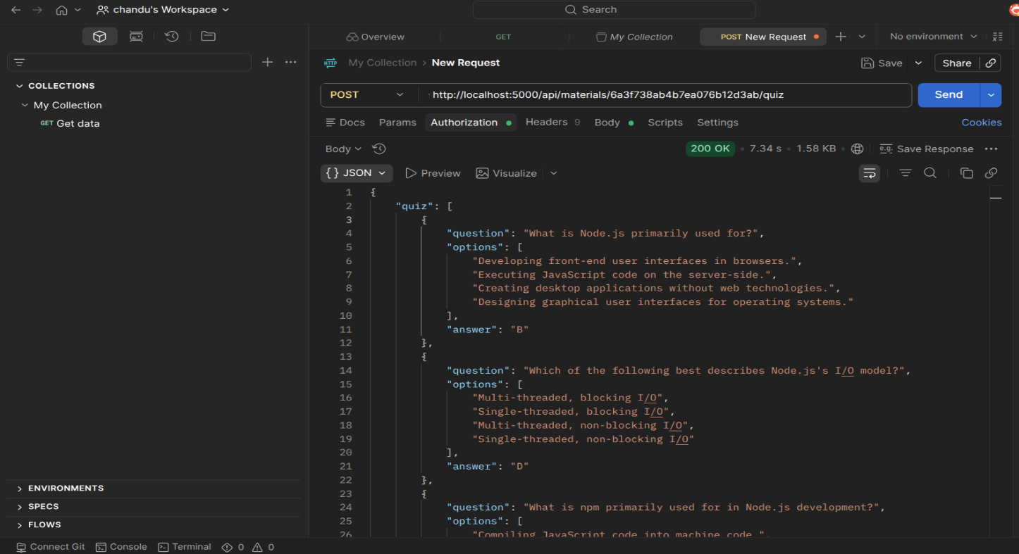

CONCLUSION
AI StudyBuddy is a scalable AI-powered educational platform designed to improve student learning and revision.
By combining React.js, Node.js, Express.js, MongoDB, Mongoose, JWT authentication, RBAC, bcrypt and Google Gemini AI, the system automates important study tasks while maintaining secure and structured resource management. Its modular architecture supports maintainability, efficient request handling and future expansion.

Github: https://github.com/kishoreananthambca2024-design/AI-study-buddy.git
Drive link: https://drive.google.com/file/d/1zYRPtfotpDYYtAuPPOnufzRa7kpZc54X/view?usp=drivesdk

